The attached Templates are not new standards or regulations, and creates no new legal obligations. The InterWest Insurance Services, LLC, Plan Templates are advisory in nature, informational in content, and is intended to assist employers in providing a safe and healthful workplace through effective prevention programs adapted to the needs of each employer or organization. The employer or organization shall be responsible for the establishment and maintenance of the program.

Any template or form shown in the InterWest Insurance Services, LLC, Plan Templates are not a form that is required to be used for the adopted program or its employees, but serves only as an example to assist you with your program design and implementation. All employers must review all aspects of the template and ensure it is accurate and relevant to the current business practice and facility. Furthermore, it is the responsibility of each employer or organization to provide a safe workplace to its employees. The attached program plan templates are advisory in nature and intended to assist employers as they strive to improve safety, health and compliance efforts.

The information contained in these templates does not certify that all unsafe conditions, violations of federal, state or local regulations or laws are in compliance, nor does it conclude that all possible infractions, hazards or hazardous conditions were considered or reported.
*Please use the table below to enter the requested information. This will fill in throughout the document. After all changes have been made delete this page before saving your Pandemic Continuity of Operations Plan*
Template Prompt | Your Response
Name of your organization: | Click or tap here to enter text.
Name or position of person handling messaging and communication during emerging infectious disease or pandemics: | Click or tap here to enter text.
Name or position of Pandemic Continuity Coordinator: | Click or tap here to enter text.
Alternate or backup to Continuity Coordinator: | Click or tap here to enter text.
List of essential functions and supporting information: | Click or tap here to enter text.
Pandemic Response Team (PRT) member names: | Click or tap here to enter text.
Emergency Alert Notification Process: | Click or tap here to enter text.
Name or position responsible for maintaining PRT member roster: | Click or tap here to enter text.
Location where PRT member roster is posted: | Click or tap here to enter text.
Location of master PRT member roster: | Click or tap here to enter text.
Systems and technologies that facilitate communication without person to person contact: | Click or tap here to enter text.
Human Resources members to contact if employee tests positive for COVID-19: | Click or tap here to enter text.

Click or tap here to enter text.

Pandemic Continuity of
Operations Plan

Click or tap here to enter text. Pandemic Continuity of Operations Plan
2020
Table of Contents
INTRODUCTION 1
PANDEMIC PLANNING ASSUMPTIONS 2
PANDEMIC RESPONSE 3
APPENDIX 1: PANDEMIC ALERT LEVELS AND ACTIONS I
APPENDIX 2: HUMAN RESOURCES VII
APPENDIX 3: TRAINING X
APPENDIX 4: RECONSTITUTION XVII
RESOURCES XVIII

INTRODUCTION
Throughout history, there have been a number of devastating pandemics that take a toll in human population. One of the most devastating pandemics was the Black Death (also known as The Plague) which killed an estimated 75-200 million people in the 14th century. Other notable pandemics include the 1918 influenza pandemic and 2009 flu pandemic (H1N1).

The World Health Organization has recognized coronavirus disease 2019 as an ongoing pandemic. Coronavirus disease 2019, abbreviated as COVID-19, where ‘CO’ stands for ‘corona,’ ‘VI’ for ‘virus,’ and ‘D’ for disease was first identified in Wuhan China. According to media reports, more than 200 countries and territories have been affected, with major outbreaks in the United States, Central China, Italy, Spain and Iran.

Since the threat to an organization’s continuity of operations is great during a pandemic outbreak; it is important for Click or tap here to enter text., to have a Pandemic Continuity of Operations plan in place to ensure it can carry out its essential functions and services. Continuing to perform essential functions and provide essential services is vital to Click or tap here to enter text., ability to remain a viable entity during times of increased threats from all hazards, manmade or natural.

While we may be forced to suspend some operations due to the severity of a pandemic outbreak, an effective Continuity of Operations Plan can assist our organization in its efforts to remain operational, as well as strengthen the ability to resume operations. Plans for maintaining essential functions during a pandemic outbreak must emphasize mitigation strategies, such as social distancing, increased hygiene, increasing telework, avoiding discretionary travel and similar approaches. Protecting the health and safety of employees must be a major focus of planning in order to ensure the continuity of essential functions.

  - PURPOSE
The purpose of Click or tap here to enter text. Pandemic Continuity of Operations plan is to provide guidance for preparation, response and recovery in the event of a pandemic. This guidance neither replaces nor supersedes any current, approved Click or tap here to enter text. emergency action plan; rather it supplements it by addressing additional considerations, challenges, and elements specific to the dynamic nature of a pandemic.

  - PANDEMIC ALERT LEVELS AND ACTIONS
The Click or tap here to enter text. will monitor the severity of the pandemic and establish continuity activation triggers to address the unique nature of the pandemic threat. The Pandemic Continuity of Operations Plan will be implemented in response to changes or “triggers” in the Federal Government (U.S) response stages. Details of preparations and response actions are listed in appendix 1.

  - CONTINUITY PLANNING
All organization personnel are to be informed regarding protective actions and/or modifications related to this plan. Messaging and risk communications during an emerging infectious disease or pandemic will be conducted by Click or tap here to enter text.. Guidance and instructions on established infection control measures such as social distancing, personnel protective equipment and telework polices are provided by Click or tap here to enter text. to assist in limiting the spread of COVID-19 at the primary and alternate worksite.

Within the workplace, social distancing measures could take the form of: modifying the frequency and type of face-to-face employee encounters (e.g., placing moratoriums on hand-shaking, substituting teleconferences for face-to-face meetings, staggering breaks, posting infection control guidelines); establishing flexible work hours or worksite, (e.g., telecommuting); promoting social distancing between employees and customers to maintain 3 to 6 feet spatial separation between individuals; and implementing strategies that request and enable employees with COVID-19 to stay home at the first sign of symptoms.

Department-specific risk assessments that identify actual risk level for all personnel and/or positions will be conducted initially and periodically thereafter from each participating department manager/supervisor. These assessments are kept as part of each department’s specific action plan documentation.

PANDEMIC PLANNING ASSUMPTIONS
In order to facilitate our planning efforts, the following assumptions shall be taken into consideration when managing a COVID-19 Pandemic:

  - STRATEGY FOR COVID-19 IMPLEMENTATION ASSUMPTIONS
- Susceptibility to the COVID-19 pandemic will be universal.
- Efficient and sustained person-to-person transmission signals an imminent pandemic.
- Illness rates will be highest among patients with critical illness and the overall case fatality rate in the United States is 2.3%
- Some persons will become infected but not develop clinically significant symptoms. Asymptomatic or minimally symptomatic individuals can transmit infection.
- While the number of patients seeking medical care cannot be predicted with certainty, in previous pandemic about half of those who become ill sought care.
- Rates of serious illness, hospitalization, and deaths will depend on the virulence of the pandemic virus and differ by an order of magnitude between more and less severe scenarios. Risk groups for severe and fatal infection cannot be predicted with certainty but are likely to include the elderly and persons with chronic or immunosuppressive medical conditions. Heart disease, hypertension, prior stroke, diabetes, chronic lung disease, and chronic kidney disease have all been associated with increased illness severity and adverse outcomes.
- Rates of absenteeism will depend on the severity of the pandemic. In a severe pandemic, absenteeism attributable to illness, the need to care for ill family members and fear of infection may reach 40 percent during the peak weeks of a community outbreak, with lower rates of absenteeism during the weeks before and after the peak. Certain public health measures (closing of schools and non-essential businesses, shelter in place orders and quarantining household contacts of infected individuals) are likely to increase rates of absenteeism.
- The typical incubation period (interval between infection and onset of symptoms) for COVID-19 is approximately 2 to 14 days. Persons who become ill may shed virus and can transmit infection during this time before the onset of symptoms.
- On average, infected person will transmit infection to approximately three other people.
- A pandemic outbreak in any given community will last about six to eight weeks for each wave of the pandemic.
- Multiple waves (periods during which community outbreaks occur across the country) of illness could occur with each wave lasting two-three months. Historically, the largest waves have occurred in the fall and winter, but the seasonality of a pandemic cannot be predicted with certainty.

  - ORGANIZATIONAL ASSUMPTIONS
- Organizations will be provided with guidance and/or direction by International, Federal, State, and/or local governments regarding current pandemic status in their area.
- Organizations will have actionable plans and procedures to assist in the ability to remain operational during a pandemic. Plans and procedures may include social distancing protocols, personal protection equipment (PPE), and temporary suspension of some non- essential activities.
- Click or tap here to enter text. has a viable Agency-wide continuity capability.
- Click or tap here to enter text. will review its continuity communications programs to ensure they are fully capable of supporting pandemic and other related emergencies, and give full consideration to supporting social distancing operations, including telework and other virtual office options.
- Click or tap here to enter text. -controlled buildings will be accessible, but right of entry may be limited.
- Click or tap here to enter text. may deploy to its alternate facilities.
- Click or tap here to enter text. may make its alternate facilities available for staff to implement social distancing protocols.
- Essential functions, operations, and support requirements will continue to be people dependent. However, human interactions may be remote or virtual, resulting in the employment of appropriate teleworking and other approved social distancing protocols.
- Domestic and International Travel restrictions implemented at the Federal, State, and local levels may affect the ability of some staff to report to work.
- Additional funding will be budgeted for the acquisition of additional equipment required for a possible surge in teleworking capabilities.

PANDEMIC RESPONSE

  - PANDEMIC RESPONSE TEAM AND PANDEMIC COORDINATOR:
Click or tap here to enter text. has designated Click or tap here to enter text. as the Pandemic Coordinator while Click or tap here to enter text. shall serve as the alternate Pandemic Coordinator. Click or tap here to enter text. will establish a Pandemic Response Team (PRT) to anticipate the impacts of a pandemic on Click or tap here to enter text. and to assist with developing strategies to manage the effects of a pandemic outbreak.

Click or tap here to enter text. PRT is comprised of the following:
[Insert PRT members below along with their contact info; Work Phone/Alternate and Work Email]
  - Pandemic Coordinator: Click or tap here to enter text.
  - Occupational Safety, Health, and Environment: Click or tap here to enter text.
  - Chief Operations Officer: Click or tap here to enter text.
  - Chief Human Resources Officer: Click or tap here to enter text.
  - Chief Information Officer: Click or tap here to enter text.
  - Chief Financial Officer: Click or tap here to enter text.
  - Chief Counsel: Click or tap here to enter text.

  - ESSENTIAL FUNCTIONS
Given the expected duration and potential multiple waves of pandemic outbreaks, Click or tap here to enter text. has reviewed the processes involved in carrying out essential functions and services in order to develop plans that mitigate the effects of the pandemic while simultaneously allowing the continuation of operations which support essential functions and services needed to sustain its mission and operations during a pandemic. The essential functions and services identified are: Click or tap here to enter text.
(Primary employees (currently perform these functions) and backup employees (cross trained, recently retired, etc.) should be determined as part of pandemic planning.)

Priority | Essential Function | Primary Employees | Backup Employees
1
2
3

  - ORDERS OF SUCCESSION
Since COVID-19 pandemic may affect regions of the United States differently in terms of timing, severity, and duration, Click or tap here to enter text. has identified orders of succession that are at least three deep per position to help assure continuity of operations over an extended period of time.
The Click or tap here to enter text. Orders of Succession are placed here.

  - DELEGATIONS OF AUTHORITY
At the height of a pandemic wave, absenteeism maybe significant, as such, Click or tap here to enter text. has established delegations of authority that are at least three deep to take into account the expected rate of absenteeism and regional nature of the outbreak to help assure continuity of operations over an extended time period.
Click or tap here to enter text. Delegations of Authority for the senior leadership and PRT members (as appropriate) are placed here.

  - CONTINUITY FACILITIES
The traditional use of our facilities to maintain essential functions and services may not be a viable option during a pandemic. Rather, safe work practices, which include social distancing and transmission interventions, reduce the likelihood of contacts with other people that could lead to disease transmission. Click or tap here to enter text. has developed preventative practices such as social distancing procedures, telework, hygiene etiquette, and cancellation of organizations non-essential activities to reduce the spread of the pandemic. Plans have also been established to relocate to an alternate facility, if applicable.
Click or tap here to enter text. Alternate Facilities are placed here.

  - COMMUNICATION PLAN
Click or tap here to enter text. will develop COVID-19 pandemic risk communications procedures for communicating with all internal and external stakeholders, including but not limited to instructions for determining the status of agency operations and possible changes in working conditions and operational hours.
The following communication systems needed to perform essential functions include:
- Click or tap here to enter text. for locations or departments, vendors, and customers
- Identify which colleagues, vendors, suppliers and systems are essential for maintaining operations at locations.
- Develop Rosters with names and telephone numbers. These rosters are maintained and updated by Click or tap here to enter text. and posted in/at Click or tap here to enter text.. Hardcopies are maintained at the Click or tap here to enter text..
Click or tap here to enter text. is used to facilitate communication without person to person contact.

  - ESSENTIAL RECORDS MANAGEMENT
Click or tap here to enter text. shall identify, protect, and ensure the ready availability of electronic and hardcopy documents, references, records, and information systems needed to support essential functions during a pandemic outbreak. Click or tap here to enter text. has identified systems, databases, and files that are needed to ensure essential functions remain operational.
Click or tap here to enter text. Essential Records plan for COVID-19 pandemic is placed here.

  - HUMAN RESOURCES
Although a COVID-19 pandemic outbreak may not directly affect the physical infrastructure of an organization, a pandemic will ultimately threaten all operations by its impact on an organization’s human resources. The health threat to personnel is the primary threat to maintaining essential functions and services during a pandemic outbreak. Click or tap here to enter text. has established plans to protect the entire employee population and their families, with additional guidance for key personnel, and other essential personnel, should a COVID-19 pandemic outbreak occur.
Click or tap here to enter text. Human Resource information is in appendix 2.

  - TEST, TRAINING AND EXERCISES
Testing, training, and exercising are essential to assessing, demonstrating, and improving an organization’s ability to maintain its essential functions and services. The organization conducts annual tests, training, and exercises to ensure sustainable social distancing techniques, and to assess the impacts of reduced staff on the performance of essential functions. The organization conducts continuity exercises to examine the impacts of COVID-19 pandemic on performing essential functions, and to familiarize personnel with their responsibilities. The organization has identified resources and trained continuity personnel, needed to perform essential functions.
The Click or tap here to enter text. continuity test, training and exercise plan is appendix 3

  - RECONSTITUTION
Reconstitution is the process whereby an organization has regained the capability and physical resources necessary to return to normal (pre-disaster) operations. The objective during reconstitution is to effectively manage, control, and, with safety in mind, expedite the return to normal operations. The Click or tap here to enter text. has developed reconstitution plans and procedures, in conjunction with local public health authorities, to ensure facilities/buildings are safe to return. The organization’s reconstitution plan should consider the possibility that not all employees may be able to return to work at the time of reconstitution and that it may be necessary to hire temporary or permanent workers in order to complete the reconstitution process. The Click or tap here to enter text. Reconstitution plan for COVID-19 pandemic is Appendix 4.

  - CONCLUSION
Maintaining Click or tap here to enter text. essential functions and services in the event of COVID-19 pandemic requires additional considerations beyond traditional continuity planning. Unlike other hazards that necessitate the relocation of staff performing essential functions to an alternate operating facility, a COVID-19 pandemic may not directly affect the physical infrastructure of the organization. As such, a traditional “continuity activation” may not be required during a COVID-19 pandemic outbreak. However, a pandemic outbreak threatens an organization’s human resources by removing essential personnel from the workplace for extended periods of time. Accordingly, the Click or tap here to enter text. continuity plan addresses the threat of a COVID-19 pandemic outbreak.

Continuity Plans for maintaining essential functions and services in a COVID-19 pandemic should include implementing procedures such as social distancing, infection control, personal hygiene, and cross-training (to ease personnel absenteeism in a critical skill set). Protecting the health and safety of key personnel, ERG members, and other essential personnel must be the focused goal of the organization in order to enable the organizations to continue to operate effectively and to perform essential functions and provide essential services during a pandemic outbreak.

APPENDIX 1: PANDEMIC ALERT LEVELS AND ACTIONS
WHO Phases |  | Federal Government Response Stages |  | Click or tap here to enter text.
INTER- PANDEMIC PERIOD
1 | No new inﬂuenza virus subtypes have been detected in humans. An inﬂuenza virus subtype that has caused human infection may be present in animals. If present in animals, the risk of human disease is considered to be low. | 0 | New domestic animal outbreak in at–risk country | Planning Stage
2 | No new inﬂuenza virus subtypes have been detected in humans. However, a circulating animal inﬂuenza virus subtype poses a substantial risk of human disease.
PANDEMIC ALERT PERIOD
3 | Human infection(s) with a new subtype, but no human-to-human spread, or at most rare instances of spread to a close contact. | 0 | New domestic animal outbreak in at–risk country
 |  | 1 | Suspected human outbreak overseas | Pandemic Alert  Level A
4 | Small cluster(s) with limited human-to-human transmission but spread is highly localized, suggesting that the virus is not well adapted to humans. | 2 | Conﬁrmed human outbreak overseas
5 | Larger cluster(s) but human-to-human spread still localized, suggesting that the virus is becoming increasingly better adapted to humans, but  may not yet be fully transmissible (substantial pandemic risk). |  |  | Pandemic Alert  Level A
PANDEMIC PERIOD
6 | Pandemic phase: increased and sustained transmission in general population. | 3 | Widespread human outbreaks in multiple locations overseas | Pandemic Alert Level B
 |  | 4 | First human case in North America | Pandemic Alert  Level B
 |  | 5 | Spread throughout United States | Pandemic Alert  Level C
 |  | 6 | Recovery and preparation for subsequent waves | Pandemic Alert Level D
Pandemic Planning and Preparation
(New domestic animal outbreak in at-risk country)
Responsible Person or  Team | Click or tap here to enter text. Action | Completed
 | Identify critical functions that must be kept in operation.
 | Identify critical supplies, e.g. Soap, disinfecting wipes, sanitizer, chlorine, necessary to maintain safe operations.
 | Identify essential personnel.
 | Identify cross training needs and conduct cross training.
 | Develop pandemic COVID-19 plan.
 | Participate in COVID-19 pandemic planning and exercises with local public health and regulatory officials.
 | Consider developing mutual aid agreements.
 | Update Standard Operating Procedures for plant operations and other essential functions.
 | Define roles and responsibilities for all personnel during a pandemic.
 | Educate all employees regarding pandemic policy (changes in work rules, etc.), infection control measures (hygiene measures, use of N-95 masks, etc) and flu symptoms.
 | Plan for supply disruptions: Develop alternate treatment chemicals, supplies, and power.
 | Acquire supplies for sanitizing and personal protection: sanitizing stations, sanitizing agents, latex/vinyl gloves, and N-95 masks.
 | Develop emergency supply kits (food, water, PPE) to critical facilities.
 | Ensure IT system is capable for telecommuting and provide secure access to appropriate employees.
 | Establish necessary pandemic policies: Emergency communications, travel, social distancing, telecommuting, sequestering critical staff on-site, screening employees for COVID-19, sick leave (for sending employees home that have exceeded sick leave limits or have no accrued sick leave).
 | Encourage employees to stay home when they have, COVID-19.
 | Set up pandemic COVID-19 surveillance notification system with local public health officials.
 | Reserve funds for emergency purchases at increased costs.
 | Encourage employees and public to develop home emergency kits (food, water, etc.) and plans.

Alert Level A – Pre-Pandemic Preparation
(Suspected human outbreaks overseas – Confirmed human outbreaks overseas)
Responsible Person or  Team | Actions | Completed
 | Remind employees regarding pandemic policy (changes in work rules, etc.) and infection control measures (hygiene measures, use of N-95 masks, etc.) and flu symptoms.
 | Review preparations for supply disruptions and staffing shortages (cross training and alternate treatment chemicals, suppliers, and backup power systems.
 | Set up sanitizing stations and provide work areas with sanitizing agents, latex/vinyl gloves, and N-95 masks.
 | Distribute emergency supply kits (food, water, personal protection equipment) to critical facilities.
 | Establish or finalize necessary pandemic policies: Emergency communications, travel, social distancing, telecommuting, sequestering critical staff on-site, screening employees for COVID-19, sick leave (for sending employees home that have exceeded sick leave limits or have no accrued sick leave).
 | Encourage employees to stay home when they have COVID-19.
 | Monitor pandemic status through https://www.cdc.gov/coronavirus/2019-nCoV/index.html and local public health.
 | Maintain contact with critical supply vendors, e.g. chlorine, electric, gas, to determine their ability to deliver supplies.
 | Suspend travel outside state when human outbreaks are confirmed.

Alert Level B – Pandemic
(Widespread human outbreaks in multiple locations overseas
– First human cases in North America)
Responsible Person or Team | Actions | Completed
 | Communicate pandemic status, and provide infection control and symptoms of COVID-19 refresher training to all employees.
 | Remind all employees to stay home when they have COVID-19.
 | Implement COVID-19screening (based on symptoms) of employees.
 | Suspend all travel.
 | Focus on conducting essential functions only.
 | Prepare to implement necessary pandemic policies for social distancing, telecommuting, sequestering critical staff on-site, screening employees for COVID-19, sick leave (for sending employees home that have exceeded sick leave limits or have no accrued sick leave).
 | Maintain contact with critical supply vendors, e.g. Cleaning, electric, gas, to determine their ability to deliver supplies.
 | Prevent access to facilities by non-employees unless necessary.
 | Prepare for use of cross trained employees.
 | Review line of succession plans and update as necessary.
 | Continue to monitor pandemic status through https://www.cdc.gov/coronavirus/2019-nCoV/index.html and local public health.
 | Provide supplies at facilities for sequestering essential staff.
 | Document actions and additional expenses.

Alert Level C – Pandemic
(Spread throughout North America)
Responsible Person or Team | Actions | Completed
 | Communicate pandemic status to all employees.
 | Focus on conducting essential functions only.
 | Remind all employees to stay home when they have COVID-19.
 | Continue COVID-19 screening (based on symptoms) of employees.
 | Consider modifications of treatment to conserve chemicals and energy.
 | Reassign staff to insufficiently staffed facilities.
 | Consider sequestering essential personnel at facilities.
 | Provide daily absentee reports to Manager.
 | Suspend all travel.
 | Eliminate all non-essential face to face meetings.
 | Provide transportation to employees as necessary.
 | Maintain contact with critical supply vendors, e.g. chlorine, electric, gas, to determine their ability to deliver supplies.
 | Continue to monitor pandemic status through pandemicflu.gov and local public health.
 | Document actions and additional expenses.
 | Keep records of employees that have recovered from COVID-19. They will be vital for maintaining operations because of their acquired immunity.

Alert Level D – Pandemic Recovery and Preparation
(Preparation for Subsequent Pandemic Waves)
Responsible Person or Team | Actions | Completed
 | Continue essential functions and evaluate reinstating non- essential activities.
 | Communicate pandemic status to all employees.
 | Stockpile essential supplies.
 | Allow necessary travel on a case by case basis.
 | Maintain contact with critical supply vendors, e.g. chlorine, electric, gas, to determine their ability to deliver supplies.
 | Restock supplies at facilities for sequestering essential staff.
 | Evaluate response and update plans.
 | Continue to monitor pandemic status through https://www.cdc.gov/coronavirus/2019-nCoV/index.html and local public health.
 | Document actions and additional expenses.
 | Remind all employees to stay home when they have COVID-19.
 | Keep records of employees that have recovered from COVID-19. They will be vital for maintaining operations because of their acquired immunity.

APPENDIX 2: HUMAN RESOURCES
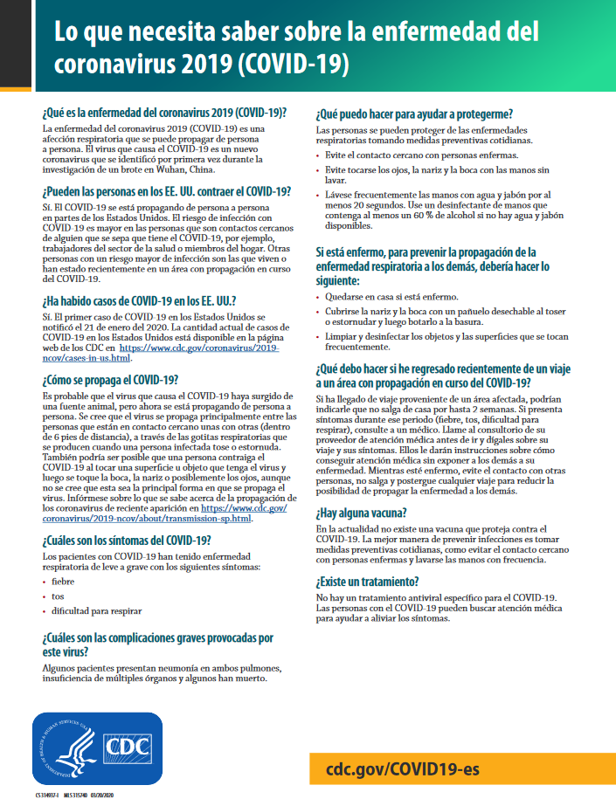
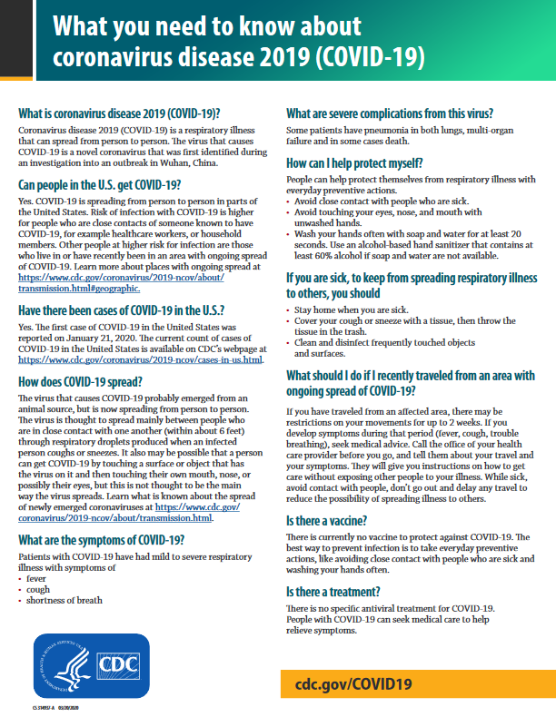

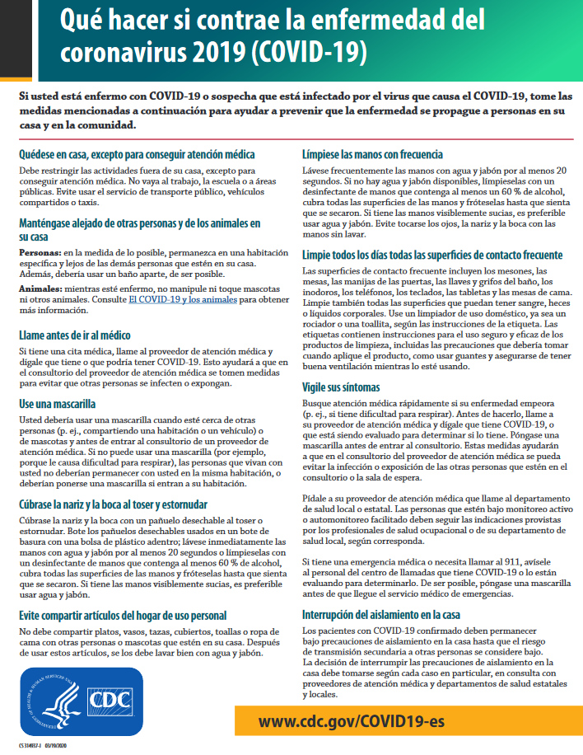
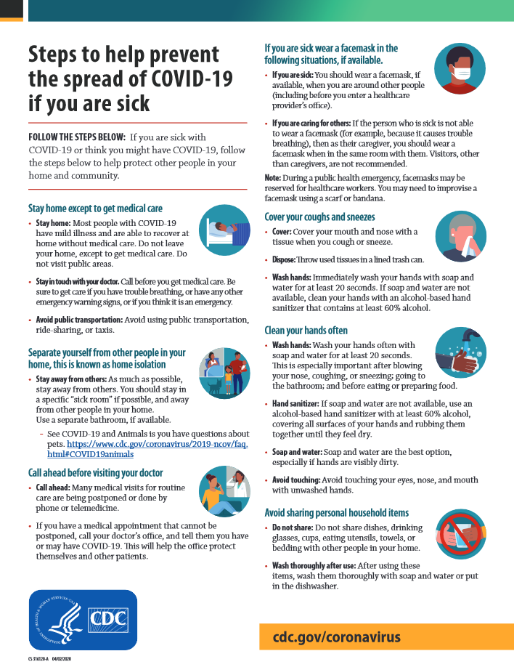

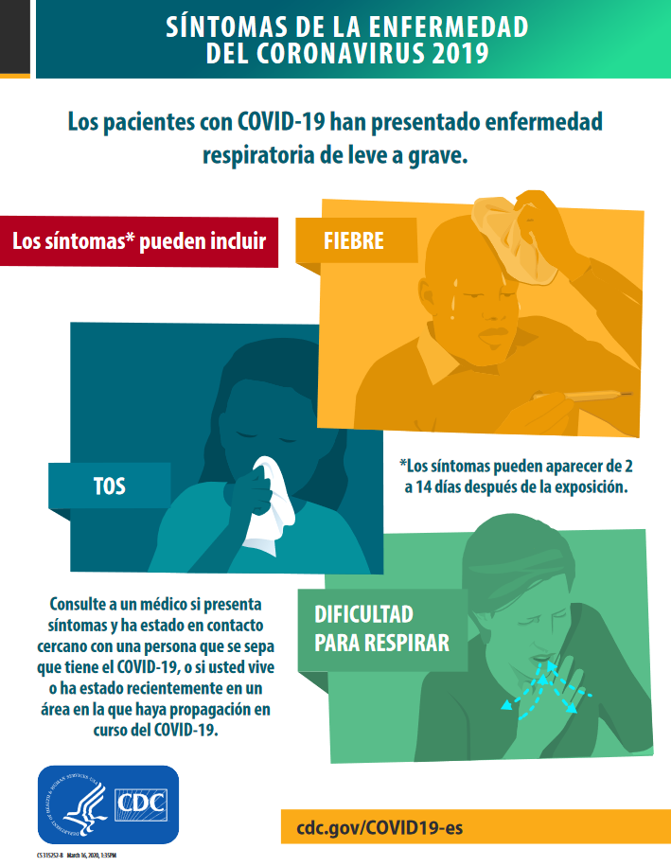
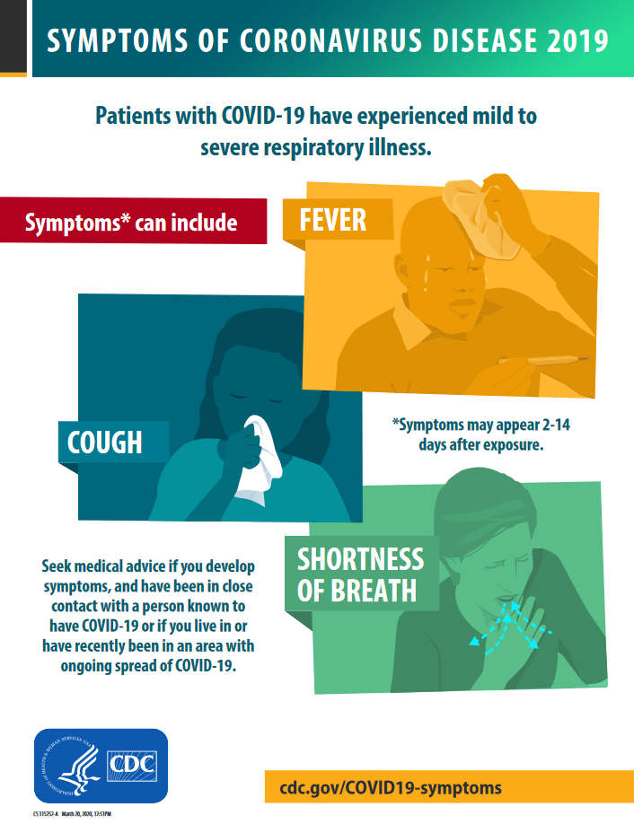
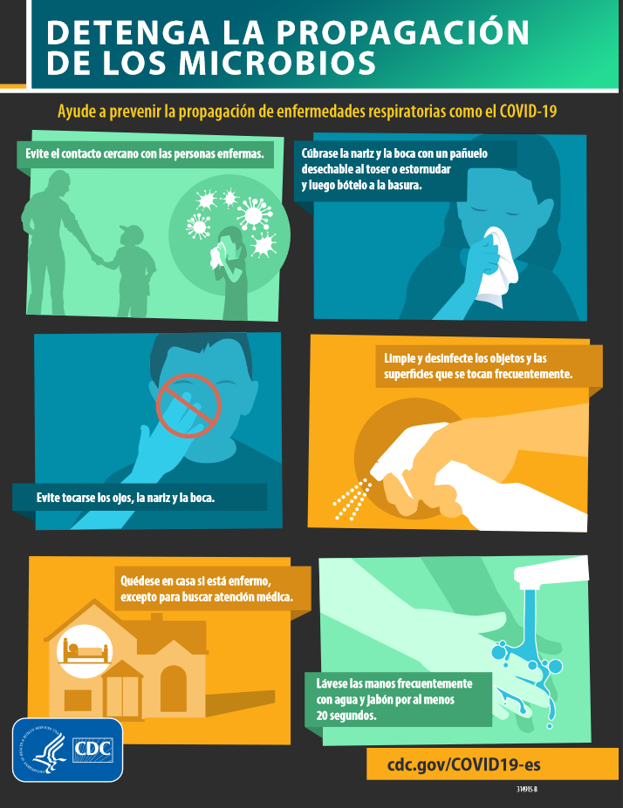
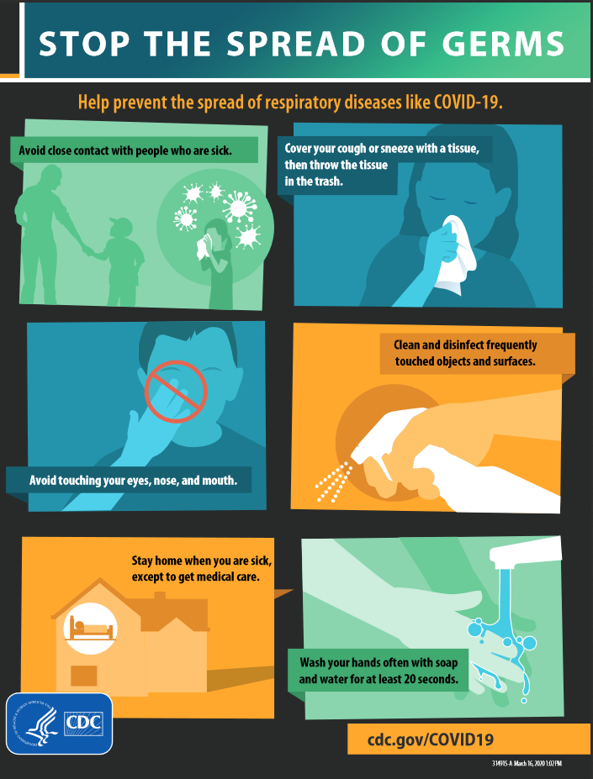

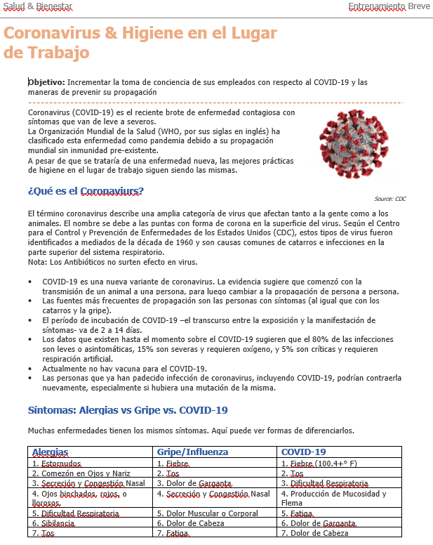
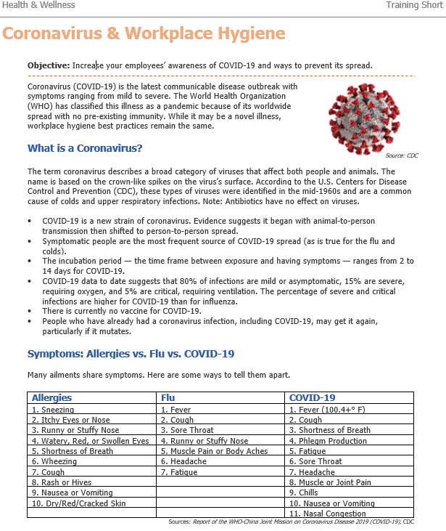

APPENDIX 3: TRAINING

  - COVID-19 Workplace Procedures
The following steps are Click or tap here to enter text. workers are required to take in order to help prevent the spread of COVID-19.

Do not report to work if:
- You have a fever
- You have a cough or shortness of breath
- You are feeling sick

- self-identify symptoms of fever, coughing, or shortness of breath each day, before the shift, mid-shift, and at home to your supervisor
- Avoid close contact with people who are sick.
- Drive to job sites by yourself—avoid passengers or carpooling.
- Don’t shake hands when greeting others. Use other non-contact methods for greeting.
- Avoiding sharing personal items with co-workers (i.e. dishes, cups, utensils, towels)
- Stay at least 6 feet away from others on job site, meetings, and training sessions
- Minimize interactions when picking up or delivering equipment or materials. Organize the placement of materials to minimize movement on the work site.
- Avoid touching your eyes, nose, or mouth with unwashed hands.
- Cover your mouth and nose with tissues if you cough or sneeze or do so into your elbow.
- Clean your hands frequently, including before and after going to the bathroom, before eating, and after coughing, sneezing, or blowing your nose.
- Wash your hands often with soap and water for at least 20 seconds. Use an alcohol-based hand sanitizer that contains at least 60% alcohol if soap and water are not available.
- Clean and disinfect high-touch surfaces on job sites—such as shared tools, machines, vehicles and other equipment, handrails, doorknobs, and portable toilets.

Pandemic Response Coordinator: Date:

1.1 Plan for the impact of a pandemic on your facility:
Completed | In Progress | Not Started
Identify a pandemic coordinator and/or team with defined roles and responsibilities
for preparedness and response planning. Include input from all management levels and staff that are involved in day-to-day operations.
 |  |  | Identify critical functions that must be maintained, e.g. disinfection.
Identify essential personnel functions and critical inputs needed to maintain operations, including locations where they may be needed during a pandemic. Ensure there is redundancy in terms of personnel (cross-training), materials (chemical suppliers, equipment suppliers, etc.), communication (phones, radios, etc.), information technology, and power (electric, gas). Establish contingency
agreements with other utilities (gas, electric) where feasible.
Identify key customers and customers with special needs, such as hospitals and
nursing homes and ensure services can be provided.
 |  |  | Cross train employees to provide backups for critical positions. Train and prepare an ancillary workforce (e.g. contractors and retirees).
Develop and plan for scenarios likely to result in an increase or decrease in demand
on your facilities during a pandemic (Loss of tourism, consumers at home instead of work, etc.)
Determine the potential impact of a pandemic on utility-related travel (e.g. quarantines, border closures that limit availability of chemicals), including suppliers who make deliveries. Encourage suppliers to develop their own pandemic
COVID-19 continuity of operations plans.
 |  |  | Find up-to-date, reliable pandemic information from the local public health agency and other sources. Make this information available to all personnel.
Establish an emergency communications plan and revise it periodically. The plan should include identification of key contacts (with back-ups), chain of communications (including suppliers and key customers), and processes for tracking and communicating utility operational status and status of employees.
Ensure public notification procedures are in place for potential scenarios.
Implement an exercise/drill to test your plan and revise it periodically. Ensure that exercises include the participation or cooperation of local health agencies,
emergency planning officials and the Environmental Protection Agency.
Notes:

1.2 Plan for the impact of a pandemic on your employees and customers:
Completed | In Progress | Not Started
Forecast and allow for employee absences during a pandemic due to factors such as personal illness, family member illness, community containment measures and
quarantines, school and/or business closures, and public transportation closures.
Implement guidelines to limit the frequency and type of face-to-face contact (e.g. handshaking, meetings, office layout, shared workstations) among employees
and between employees and customers. Take into consideration delivery personnel who would interact with employees. (See CDC recommendations.)
 |  |  | Consult local public health pandemic coordinators regarding COVID 19 testing.
Evaluate employee access to and availability of healthcare services during a
pandemic, and improve services as needed.
Evaluate employee access to and availability of mental health and social services
during a pandemic, including corporate, community, and faith-based resources, and improve services as needed.
Identify employees and key customers with special needs, and incorporate the
requirements of such persons into your preparedness plan.
NOTES:

1.3 Establish policies to be implemented during a pandemic:
Completed | In Progress | Not Started
Establish policies for employee attendance, sick-leave absences and compensation unique to a pandemic (e.g. non-punitive, liberal leave), including policies on when a previously ill person is no longer infectious and can return to
work after illness.
Establish policies for ﬂexible worksite (e.g. telecommuting) and ﬂexible work hours (e.g. staggered shifts). Take into account that longer shifts and onsite sleeping accommodations may reduce potential exposure to key workers.
Consider needs and conditions (food, sleeping accommodations, family arrangements, etc.) for sequestering on-site critical staff.
Establish policies for preventing COVID-19 spread at the worksite (e.g. promoting respiratory hygiene/cough etiquette, sanitizer stations, disinfecting work areas
and break rooms, and prompt exclusion of people with COVID-19 symptoms).
Establish policies for employees who have been exposed to pandemic inﬂuenza, are suspected to be ill, or become ill at the worksite (e.g. infection control
response, immediate mandatory sick leave).
Establish policies for teleconferencing and videoconferencing to limit face to face
contact.
Establish policies for travel to affected geographic areas and guidance for
employees returning from affected areas (refer to CDC travel recommendations).
NOTES:

1.4 Allocate resources to protect your employees and customers during a pandemic:
Completed | In Progress | Not Started
Provide sufficient and accessible infection control supplies (e.g. alcohol sanitizer stations, tissues, N-95 facial masks and receptacles for their disposal) at all work-
related locations.
Enhance communications and information technology infrastructures as needed to
support employee telecommuting and remote customer access.
 |  |  | Ensure availability of medical consultation and advice for emergency response.
NOTES:

1.5 Communicate to and educate your employees:
Completed | In Progress | Not Started
Develop and disseminate programs and materials covering pandemic fundamentals (e.g. signs and symptoms of COVID-19, modes of transmission),
personal and family protection and response strategies (e.g. hand hygiene, use of
N-95 masks, coughing/sneezing etiquette, contingency plans).
Anticipate employee fear and anxiety, rumors and misinformation and plan
communications accordingly.
 |  |  | Ensure that communications are culturally and linguistically appropriate.
 |  |  | Disseminate information to employees about your pandemic preparedness and response plan.
 |  |  | Provide information for the at-home care of ill employees and family members.
Develop platforms (e.g. hotlines, dedicated websites) for communicating pandemic status and actions to employees, vendors, suppliers, and customers
inside and outside the worksite in a consistent and timely way, including redundancies in the emergency contact system.
Identify community sources for timely and accurate pandemic information
(domestic and international) and resources for obtaining countermeasures.
NOTES:

1.6 Coordinate with external organizations and help your community:
Completed | In Progress | Not Started
Collaborate with insurers, health plans, and major local healthcare facilities to
share your pandemic plans and understand their capabilities and plans.
Collaborate with local public health officials, Environmental Protection Agency officials and/or emergency responders; participate in their planning and training, share your pandemic plans, and understand their capabilities (e.g. surveillance)
and plans.
Communicate with local and/or state public health agencies and/or emergency
responders about the assets and/or services your utility may be able to contribute to the community.
Share pandemic continuity of operations best practices with other organizations and
professional associations to improve community response efforts.
NOTES:

APPENDIX 4: RECONSTITUTION

  - Confirmed COVID-19 Cases

What to do if you your employees test positive for COVID-19
Show concern – Your employee may be upset and worried about their family members and coworkers. Listen as they share their feelings and offer to be there for them if they need someone to talk to.
Ask the employee which coworkers they’ve been in close contact with over the prior two weeks (per CDC - within 6 feet for a prolonged period of time). Write down their names.
Do NOT discuss with others. Reach out to HR immediately and provide: 1. The name of the employee diagnosed and 2. The names of all coworkers they’ve identified as having had close contact.
- Click or tap here to enter text.
HR will follow appropriate protocols for alerting the employees who may have been in contact with the diagnosed employee and will refer them to the CDC website for advice for their individual situation.

If employee reports to work exhibiting COVID-19 symptoms
Send your employee home – Provide your employee with the link to the CDC’s guidance provided via this link:
https://www.cdc.gov/coronavirus/2019-ncov/if-you-are-sick/steps-when-sick.html

If employee reports a household member who has tested positive
Send your employee home – Your employee should stay home and self-quarantine until cleared by a qualified medical professional.
https://www.cdc.gov/coronavirus/2019-ncov/hcp/disposition-in-home-patients.html

Perform enhanced cleaning and disinfection after persons suspected/confirmed to have COVID-19 have been in the facility:
If a sick employee is suspected or confirmed to have COVID-19, follow the CDC cleaning and disinfection recommendations.

RESOURCES

CDC-COVID-19
https://www.cdc.gov/coronavirus/2019-nCoV/index.html

Clean and disinfect high-touch surfaces on job sites and in offices
https://www.cdc.gov/coronavirus/2019-ncov/community/organizations/cleaning-disinfection.html

Special guidance for older workers and people with underlying health conditions
https://www.cdc.gov/coronavirus/2019-ncov/need-extra-precautions/people-at-higher-risk.html

OSHA
https://www.osha.gov/SLTC/covid-19/
OSHA Interim Guidance for preparing workplaces for COVID-19
https://www.osha.gov/Publications/OSHA3990.pdf

CalOSHA
https://www.dir.ca.gov/dosh/coronavirus/General-Industry.html

CDPH
https://covid19.ca.gov/

NIOSH
https://www.cdc.gov/niosh/emres/2019_ncov.html

WHO
https://www.who.int/emergencies/diseases/novel-coronavirus-2019

